# Project Report

### Class: TY-IC

### Div:- B

### Subject:- Process Instrumentation

### Group No.:- 2

### Group Members:-

|  |  |  |
| --- | --- | --- |
| Roll No | Name | Gr. No. |
| 03 | Aditya Hingole | 11910697 |
| 04 | Pratik Hublikar | 11910250 |
| 06 | Atharva Ingle | 11911080 |
| 12 | Saurabh Jejurkar | 11910324 |
| 23 | Rachita Kalambarkar | 11910026 |

# 

**Course Project:- Temperature Control by using PID**

**Objective:-** Tune a discrete PID controller and test the performance with a series of setpoint changes over 10 min in the sequence from 23 degree C initially, 50 degree C at 10 sec, and 40degree C at 300 sec. Modify the tuning parameters to achieve a low Integral Absolute Error between the measured temperature and the setpoint.

**Tools used:-** VSCode, Google Colab

**Programming Language used:-** Python

**Circuit Components:-** Arduino Uno, Heater, LED, Temperature Sensors

Instead of Arduino Uno and other hardware we have used TClab module for simulation and to generate the sensors data. This library helps us to generate similar real time Arduino Board data.

**Circuit Diagram:-**

This is expected circuit diagram for hardware.

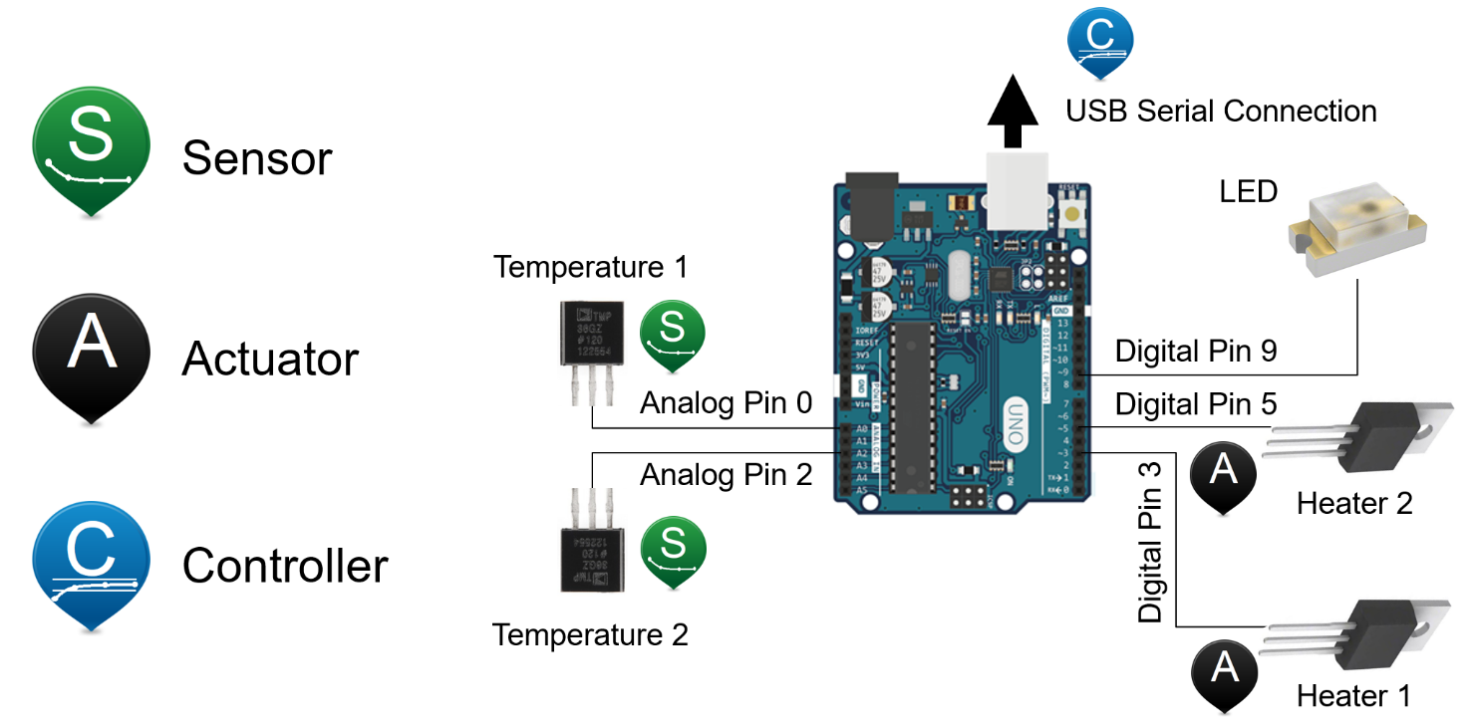

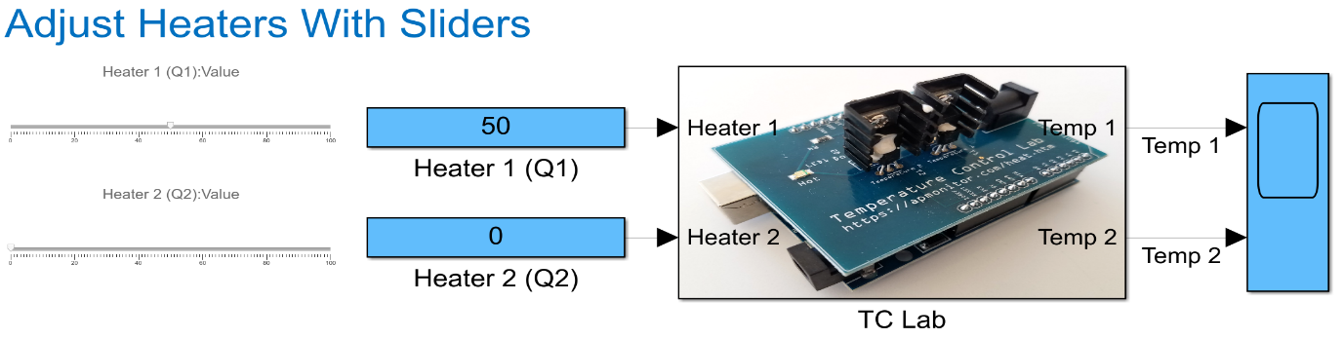

**TCLab PID Control Simulator:-**

A simulator is a useful tool to help evaluate changes in tuning before testing on a physical system. Use the PID simulator to find acceptable control performance that minimizes the integral absolute error between the setpoint and measured temperature.

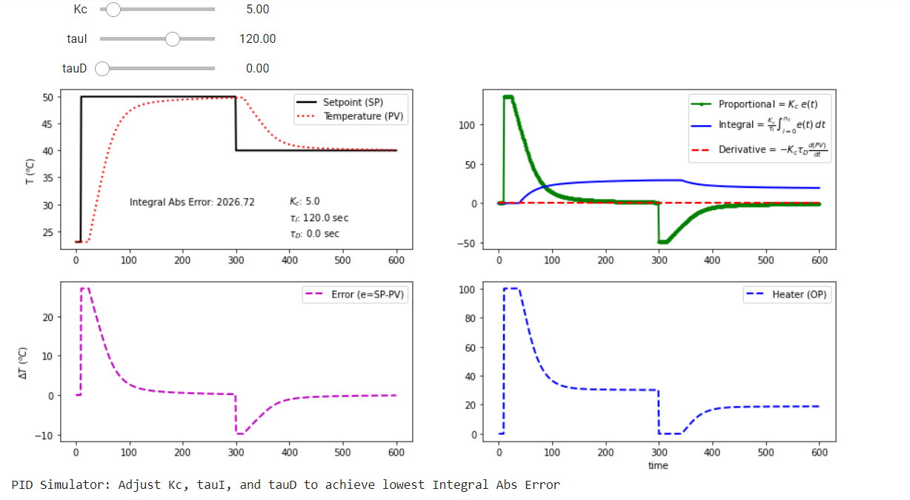

**PID control validation:-**

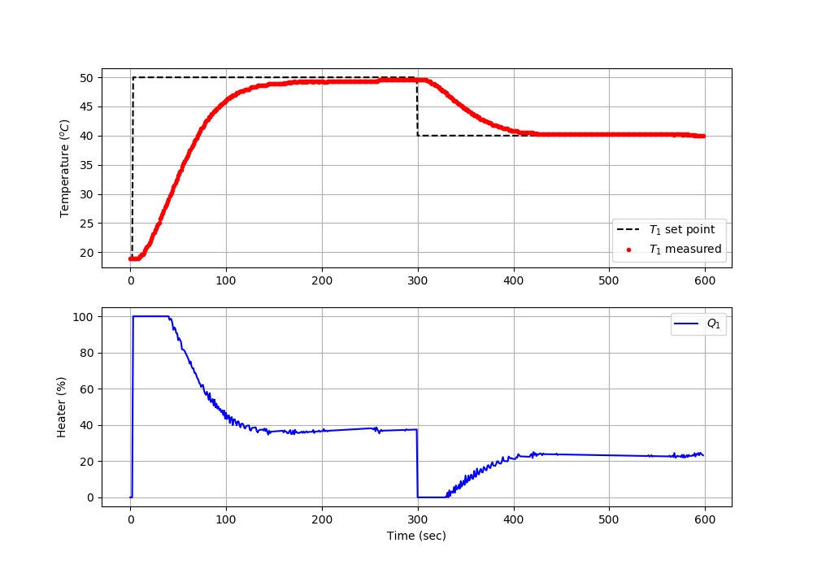



Simulation/ Final output

**Conclusion:-**

The value obtained by Arduino simulation= 2190.55

The value generated by python code= 1731.72

Mathematical value is nearly equal to Practical value.

# 